3.1 Compiler vs. Interpreter
An interpreter translates some form of source code into a target representation that it can immediately execute and evaluate. The structure of the interpreter is similar to that of a compiler, but the amount of time it takes to produce the executable representation will vary as will the amount of optimization. The following diagram shows one representation of the differences.
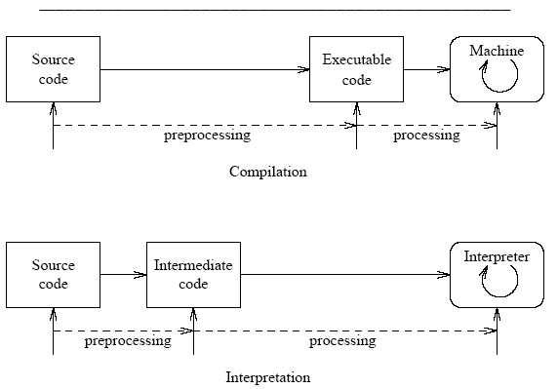
Compiler characteristics:
- spends a lot of time analyzing and processing the program
- the resulting executable is some form of machine- specific binary code
- the computer hardware interprets (executes) the resulting code
- program execution is fast
Interpreter characteristics:
- relatively little time is spent analyzing and processing the program
- the resulting code is some sort of intermediate code
- the resulting code is interpreted by another program
- program execution is relatively slow
The above characteristics are typical. There are well-known cases that are somewhere in between, such as Java with it's JVM.

